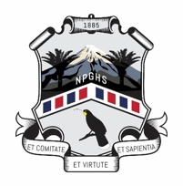 | New Plymouth Girls' High School  ASSESSMENT AUTHENTICITY FORM – 2023

Student Name: | Kawai Huia:
Subject & Level: | Class Teacher:

I understand that if I submit work in this subject at any time during the year that is not entirely my own:
- I will automatically receive a Not Achieved
- my parents will be informed
- a second serious breach of the Authenticity Procedures will result in disciplinary action.

I understand that all books, internet sites and people who have in any way assisted me must be named in the bibliography attached to my work.

I understand that copying chunks of work from books or internet sites without clearly identifying the passage and naming the author of it, as outlined by my teacher, is plagiarism and as such will be regarded as cheating.

I understand that I must meet milestones for each standard as this will be used to ensure my work is on track and also that it is my own work.

In Portfolio subjects and standards, I understand that my teacher must sign off each milestone, as milestones are on-going evidence of authenticity. Failure to have milestones signed off means the school cannot verify the work as my own therefore it will not be submitted to NZQA or I will receive a Not Achieved.

Signature of student:

Date:

Teachers must file this Authenticity Form in your department Team for the duration of 2023

