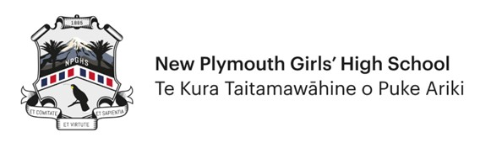

QUALIFICATION RESULT QUERIES – 2024

Name: ______________________________________ Date: ___________________________
(Full legal name)

NSN: _______________________________________ Your email:______________________

Cell phone no.: _______________________________ Home phone:____________________

What year were you in 2023? Yr10 /Yr11 /Yr12 /Yr13

Are you returning to school in 2024? Yes / No

Is your gaining University Entrance dependant on the outcome of this query?
(If so fill in details at bottom of page) Yes / No

Is your query about External or Internal Results? Ext / Int
(If your query is related to External Results – you need to contact NZQA directly)

All internal results queries must have a photocopy of your Results Notice attached – do not submit this form without including your results.

For Internal Result queries |  |  | For Grade errors – changes must be signed & verified by your 2023 Subject Teacher or HOD
Subject(s) (Domain) | Registration Number(s) | What is your query? | Grade on Result Notice | Correct Grade | Grade Verified by Teacher /HOD

If the outcome of this query is required urgently for University Entrance state
Name of your 2024 University
Course you will be undertaking
If you are short on the credits required to gain UE – what do you think you need to complete UE (i.e. 3 Chemistry credits)?
Have you contacted the HOD of the Department concerned yet? | Y / N
Are you enrolled with Te Kura Summer School | Y / N
If so, list what standards you are working on and their credit value

Other Queries:_________________________________________________________________________
_____________________________________________________________________________________
_____________________________________________________________________________________

If emailing this form – forward to Miss Crawford jcrawford@npghs.school.nz

