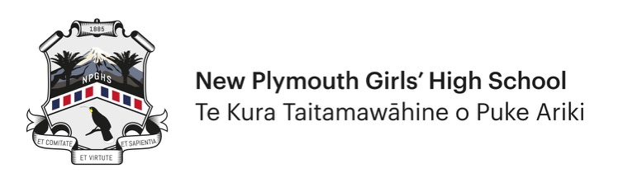
Application for Iti Rearea Award

ITI REAREA AWARDS PER YEAR – 2024 Onwards
Iti Rearea will only be awarded once per year for the same specific area within the
Iti Rearea categories i.e. once per year in Dance or Kayaking etc.

Information for all applicants
- Use this form for all Iti Rearea applications.
- Applicants must complete and submit the form electronically. They must also forward a copy to the Teacher in Charge of the activity for that teacher to verify.
- Applicants should be Year 9, 10 or Year 11 students. Year 12 students competing in events where participants are 16 years and under, sometimes known as U17 events, should also use this form to apply for Iti Rearea Awards.
- This is not a team/group award. If you are part of a successful team/group then you, and each team/group member, are required to complete separate applications forms. Individual members are considered separately based on their personal contribution to the team/group.
- Copies of any supporting evidence should be attached to your application.
- Please complete all sections where applicable.
- All applications will be considered at the next Sports and/or Iti Rearea Committee meeting.
- Generally, you will not be notified personally of the decision as all Iti Rearea Awards are confidential up to the awards ceremony.

Criteria for application
- This is an individual award which recognises a student’s performance at the highest level.
- Applicants must have represented NPGHS wherever that code/activity is offered by the school and done so in the year of the award.
- Applications in sports/activities not offered by the school will be considered.
- There must also be evidence of commitment and hard work within their sport/activity.
- The degree of difficulty in achieving success will be considered.
  - Degree of difficulty may include:
    - A compilation of significant achievements in a particular field.
    - Numbers participating in the sport/event/activity.
    - Competing in the highest award group for their age (excluding B teams e.g. U16 B grade and non-championship events).
    - Selected through an open trial process.
- Applicants must either have:
  - Won a National title/event in their age group (16 years and under).
  - Been selected to represent New Zealand in their age group (16 years and under), (not development squads) and have competed in the event.
  - Won a placing in a World Event (World Championships or Youth Olympics) and have competed in the event.

Section 1 – Application Details

Personal details
First Name |  | Surname
Date of Birth |  | Year Level

Contact details
Street Address |  | Cell No
Suburb |  | Home Phone
Town |  | Email  Address

Achievements
Please list relevant achievement(s) for the current year to support your Iti Rearea application.
Iti Rearea Category | Academic/Arts/Sport/Cultural  (circle one)
Sub-Category | Specify Code/Type:
Event(s) competed in/ Competition(s) won /Title(s) gained

Other supporting
information

Supporting Contacts
Teacher in Charge – Name: | Cell Phone: | Email:
OR Other Person in Charge – Name: | Cell Phone: | Email:
Relevant website for results (provide link):

Section 2 – Verification

Student Verification
I verify that all the details above are accurate.
Student Name
Signature |  | Date

Teacher / Coach in Charge Verification
I verify that all the details above are accurate.
Teacher/Person in Charge Name
Signature |  | Date

