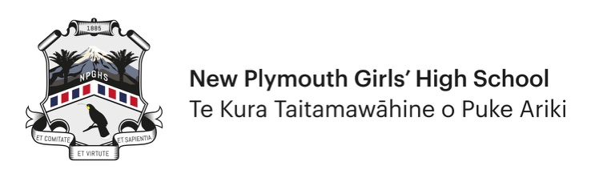
Application for Sports Honours Award Only

HONOURS AWARDS PER YEAR – 2024 Onwards
Honours will only be awarded once per year for the same specific area within the Honours categories i.e. once per year in Kayaking or Basketball etc.

Information for all applicants
- Use this form for all Sports Honours applications only.
- Applicants must complete and submit the form electronically. They must also forward a copy to the Teacher in Charge of the activity for that teacher to verify.
- Applicants should be Year 12 or Year 13 students. Only in exceptional circumstances will Year 11 students be considered for an Honours Award.
- This is not a team award. If you are part of a successful team then you, and each team member, are required to complete separate application forms. Individual members are considered separately based on their personal contribution to the team.
- Record all achievements for the current year/season only.
- Copies of any supporting evidence should be attached to your application.
- Please complete all sections where applicable.
- All applications will be considered at the next Sports Honours and Honours Committee meetings.
- Generally, you will not be notified personally of the decision as all Honours Awards are confidential up to the awards ceremony.

Criteria for application
- This is an individual award which recognises a student’s performance at the highest level.
- Applicants must have represented NPGHS wherever that code is offered by the school and done so in the year of the award.
- Applications in sports not offered by the school will be considered.
- There must also be evidence of commitment and hard work within their sport.
- The degree of difficulty in achieving success will be considered.
  - Degree of difficulty may include:
    - A compilation of significant achievements in a particular field.
    - Numbers participating in the sport or event.
    - Competing in the highest award group for their age (excluding B teams e.g. U18 B grade and non-championship events).
    - Selected through an open trial process.
- Applicants must either have:
  - Won a National title/event in their age group (17 years and over) or open women.
  - Been selected to represent New Zealand in their age group (17 years and over) or open women (not development squads) and have competed in the event.
  - Won a placing in a World Event (World Championships or Youth Olympics) and have competed in the event.

Section 1 – Application Details

Personal details
First Name |  | Surname
Date of Birth |  | Year Level

Contact details
Street Address |  | Cell No
Suburb |  | Home Phone
Town |  | Email  Address

Achievements
Please list relevant achievement(s) for the current year to support your Sports Honours application.
List only events you are applying for Honours in (not previously awarded events)
Honours Category | Sports
Sub-Category | Specify Code:

Results from January to December for Year 11, 12 or 13 (Circle one)

Event 1 | International National Regional / Provincial  (Circle one)
 | Name of event/ title gained
 | How did you qualify for the event?
 | What was the age group for the event?
 | Relevant website for results (provide link)
How many schools competed?
(A teams only)
 | How many people approximately, competed in the event? (A teams only)
 | What was your/team result or achievement?
 | Coach name and number (email and cell)
 | Club affiliation (if relevant)
 | Add any other supporting information

Results from January to December for Year 11, 12 or 13 (Circle one)

Event 2 | International National Regional / Provincial  (Circle one)
 | Name of event/ title gained
 | How did you qualify for the event?
 | What was the age group for the event?
 | Relevant website for results (provide link)
How many schools competed?
(A teams only)
 | How many people approximately, competed in the event? (A teams only)
 | What was your/team result or achievement?
 | Coach name and number (email and cell)
 | Club affiliation (if relevant)
 | Add any other supporting information

Results from January to December for Year 11, 12 or 13 (Circle one)

Event 3 | International National Regional / Provincial  (Circle one)
 | Name of event/title gained
 | How did you qualify for the event?
 | What was the age group for the event?
 | Relevant website for results (provide link)
How many schools competed?
(A teams only)
 | How many people approximately, competed in the event? (A teams only)
 | What was your/team result or achievement?
 | Coach name and number (email and cell)
 | Club affiliation (if relevant)
 | Add any other supporting information

Section 2 – Verification

Student Verification
I verify that all the details above are accurate.
Student Name
Signature |  | Date

Teacher/Coach in Charge Verification
I verify that all the details above are accurate.
Teacher/Person in Charge Name
Signature |  | Date

