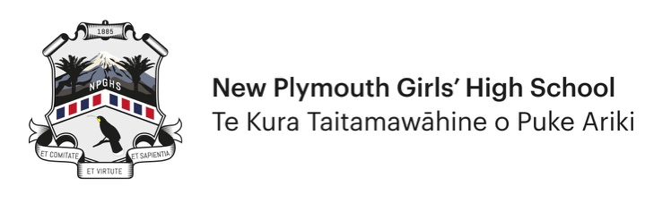
Application for all Non-Sports Honours Awards

HONOURS AWARDS PER YEAR – 2024 Onwards
Honours will only be awarded once per year for the same specific area within the Honours categories i.e. once per year in Dance or Writing etc.

Information for all applicants
- Use this form for all Non-Sports Honours applications.
- Applicants must complete and submit the form electronically. They must also forward a copy to the Teacher in Charge of the activity for that teacher to verify.
- Applicants should be Year 12 or Year 13 students. Only in exceptional circumstances will Year 11 students be considered for an Honours Award.
- This is not a group award. If you are part of a successful group then you, and each group member, are required to complete separate application forms. Individual members are considered separately based on their personal contribution to the group.
- Record all achievements for the current year only.
- Copies of any supporting evidence should be attached to your application.
- Please complete all sections where applicable.
- All applications will be considered at the next Honours Committee meeting.
- Generally, you will not be notified personally of the decision as all Honours Awards are confidential up to the awards ceremony.

Criteria for application
- This is an individual award which recognises a student’s performance at the highest level.
- Applicants must have represented NPGHS wherever that activity is offered by the school and done so in the year of the award.
- There must also be evidence of commitment and hard work.
- Applications in activities not offered by the school will be considered.
- Consideration will be given to the degree of difficulty in achieving success and may include a compilation of significant achievements in a particular field.

Section 1 – Application Details

Personal details
First Name |  | Surname
Date of Birth |  | Year Level

Contact details
Street Address |  | Cell No
Suburb |  | Home Phone
Town |  | Email  Address

Achievements
Please list relevant achievement(s) for the current year to support your Non-Sports Honours application.
Honours Category | Arts/Cultural (circle one)  (Applications are not made for Leadership or Academic categories unless you have something significant outside school you wish to be considered for)
Sub-Category | Specify Type:
Event(s) competed in/ Competitions won

Other supporting
information

Supporting Contacts
Teacher in Charge – Name: | Cell Phone: | Email:
OR Other Person in Charge – Name: | Cell Phone: | Email:
Relevant website for results (provide link):

Section 2 – Verification

Student Verification
I verify that all the details above are accurate.
Student Name
Signature |  | Date

Teacher / Person in Charge Verification
I verify that all the details above are accurate.
Teacher/Person in Charge Name
Signature |  | Date

